**SQL Select Practice**

**Question made:** Harry Quimbay

**Lead discussion:** Chrysologue

**Question:** How many orders has each store processed?

**Query Statement:**

use bike;

SELECT c.store_id, store_name, COUNT(*) AS number_of_order FROM cust_order c JOIN store s ON c.store_id = s.store_id GROUP BY c.store_id;

**Screenshot:**

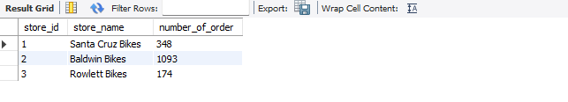

**Question made:** Mahonrry Gonzalez

**Lead discussion:** Paul Anguiano

How many customers from California have bought from Santa Cruz Bikes store?

**Query Statement:**

SELECT COUNT(distinct c.customer_id) AS QTY, c.state, s.store_name FROM customer c JOIN cust_order co ON c.customer_id = co.customer_id JOIN store s ON co.store_id = s.store_id WHERE c.state = 'CA' AND s.store_name = 'Santa Cruz Bikes';

**Screenshot:**



**Question made:** Mario Brino

**Lead discussion:** Mario Brino

**Question:** What is the top-selling store?

**Query Statement:**

USE bike;

SELECT s.store_name FROM store s WHERE s.store_id = (SELECT MAX(top.store_id) AS store_id FROM (SELECT co.store_id, SUM(coi.quantity * p.list_price * (1 - coi.discount)) AS grand_total FROM cust_order_item coi JOIN product p ON p.product_id = coi.product_id JOIN cust_order co ON co.cust_order_id = coi.cust_order_id GROUP BY co.store_id ORDER BY grand_total DESC) top);

**Screenshot:**

